Uncovering and Discovering Hidden History

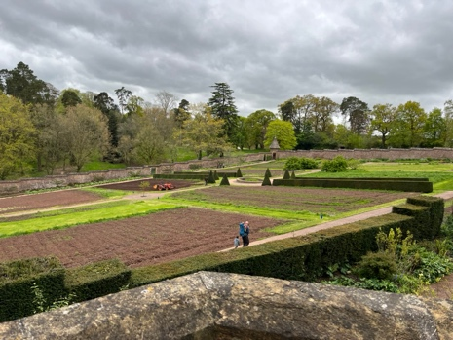
The Forum will take place on:

Friday 11th Oct. at Knightshayes
10:00am – 5:00pm, registration from 9:00am

Saturday 12th Oct. Visits to other walled kitchen gardens
10:00am - 4:00pm
- times may be subject to change

Tickets for both days: £160 – or Friday only £95; Saturday only: £65

Tickets will include: talks, lunch & refreshments on both days, entry and tours of gardens.
We can offer concessions to full-time students: Friday £65, Saturday £50.
Tell us where you are studying and the course you are undertaking

Name: …..

Address: ….

Email: ….. Telephone/mobile: …..

Organisation/Garden/other: …..

I am/we are members of: National Trust RHS English Heritage

I/we would like to book …… place(s) for the WKGN Forum 2024, Knightshayes

Both days: yes/no Friday only: yes/no Saturday only: yes/no

Please send online payment to:

Walled Kitchen Gardens Network sort code: 20-53-22 acct. no: 80691658

Complete and return form to: lucypitman@virginmedia.com or send to the address below
If you require an invoice, and for card payments please contact us on the same email

