**Historic Fruit and Kitchen Gardens**

**Newsletter number 7, May 2024**

|  |  |  |
| --- | --- | --- |
|  |  |  |
| *Susan Campbell’s book finally translated into French* | | |
|  *The Royal Kitchen Garden* *at Graasten Palace, Denmark © Slots- og Kulturstyrelsen*  **_______________________________________** | | |

**Two years after Chambord, and three months before we meet again at Culinary Estate Parc Broekhuizen in Leersum, the month of June 2024 will be special for the friends of the *European Symposium on the conservation of fruit and kitchen gardens* - ~~since~~**

* **On June 6, the first chapter of Susan Campbells “*A History of Kitchen Gardening” will be released online in French.***[Do you want this line in italic?]
* **On June 7, a new online conference takes place with the presentation of a royal kitchen garden still used by Royals.** [this would sound better as still used by the Royal family.

**________________________________________**

**French translation of Susan Campbell’s *A History of Kitchen : Gardening* available online**

In tribute to Susan Campbell and to the extensive research she has done into historic kitchen gardens, and as announced in our last newsletter, Alexia de Buffévent, Anne-France Loumaye, Alix de Saint Venant and Michel Schlosser, all from Amis du Potager du Roi, have decided to translate Susan Campbells book *A History of Kitchen Gardening* into French.

There are many reasons why Susan’s book is unique. It is a very practical and very rich book that reflects not only the existing literature, but is also nourished by all the observations Susan collected during her many visits to historical fruit and kitchen gardens all over the world. She visited 650 kitchen gardens! Another uniqueness of Susan’s book is the organization of the material: rather than reviewing the evolution of kitchen gardens at different historical periods, Susan analyses in 19 chapters the evolution of 19 dimensions of kitchen gardening: location, water, walls, etc..

As it is not everybody who enjoys reading beautiful English, we hope that this translation will make this unique insight into the historic evolution of the design of and the care for historic fruit and kitchen gardens, which is also a practical guide for anyone looking to recreate a historic kitchen garden, available to all our French speaking friends. Over the coming months we will post a chapter of the book every few weeks on our website www.potagershistoriqueshistorickitchengardens.eu. The Introduction and first chapter will go online on June 6.

**__________________________________****______**

**Online conference June 7, 2024**

Our next online conference on Friday June 7, 2024, 10h - 12h (9 - 11am UK time) will take you to two very different kitchen gardens in both England and Denmark. We start in Beaulieu, Hampshire, in the south of Britain. Here Rachel Parsons, a Kew trained gardener, is in charge of the Fairweather’s teaching garden, Patrick’s Patch. Rachel is supported by a loyal group of garden volunteers and Primary school children who regularly visit to learn gardening skills and understand where our food comes from.

On we go to Denmark, where Tanguy Laviolette from the Danish Agency for Culture and Palaces will give us an overview of the kitchen gardens the Agency manages before focusing on the Royal Kitchen Garden at Graasten Palace. This kitchen garden in the south of Denmark opened for the public in 2020. It produces fruit and vegetables for the royal dining table. In the kitchen garden, there is also a focus on learning about nature and the growing of food. Please register at [amisdupotagerduroi@yahoo.fr](mailto:amisdupotagerduroi@yahoo.fr) to receive the link to this webinar.

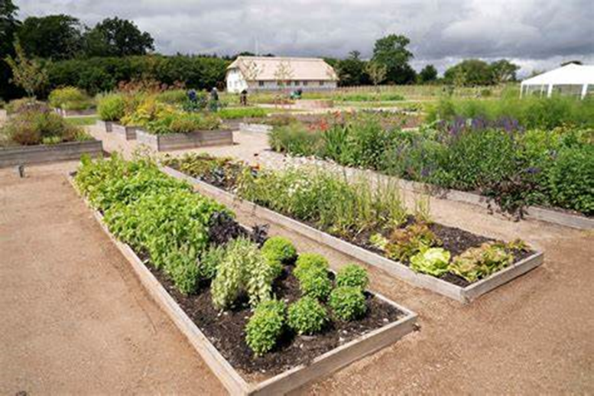  
 *The Royal Kitchen Garden* *at Graasten Palace ©Claus Fisker, Ritzau Scanpix*

**________________________________________**

**Join us at the Second European symposium on the conservation of fruit and kitchen gardens on September 5**

You are kindly invited to join us on Thursday, September 5, 2024 at Culinary Estate Parc Broekhuizen in Leersum, The Netherlands. During this day you will meet head gardeners, heritage gardeners, estate owners and researchers of historic kitchen gardens from all over Europe and you can join in the discussions on the theme ‘Future in the past - Conservation through sustainable innovation’.  
Wednesday evening, September 4 a meet & greet is organised with drinks and small bites, including a guided tour through the historic kitchen garden of Vollenhoven Estate in Bilthoven.  
Friday, September 6 an optional excursion is offered to the gardens of Loo Palace in Apeldoorn and the historic walled kitchen garden of Twickel Estate in Ambt Delden.

For the full conference programme and the registration form go to: [www.skbl.nl/the-second-european-symposium-on-the-conservation-of-historic-fruit-and-kitchen-gardens-en/](http://www.skbl.nl/the-second-european-symposium-on-the-conservation-of-historic-fruit-and-kitchen-gardens-en/)

*****The kitchen garden at Culinary Estate Parc Broekhuizen ©Parc Broekhuizen.*

**________________________________________**

**Save the date – October 11-12, 2024: WKGN Forum**

Friday 11th and Saturday 12th October 2024 the Walled Kitchen Garden Network will host its annual forum. More information on the programme to follow.

**________________________________________**

You receive this email because you participated in one of our online conferences or attended the symposium at Chambord Castle.  
Our mailing address is: [contact@potagershistoriqueshistorickitchengardens.eu](mailto:contact@potagershistoriqueshistorickitchengardens.eu)  
Copyright © 2024 European symposium on the conservation of historic fruit and kitchen gardens. All rights reserved.